PROVISIONAL

Maastricht Innovation in Higher Education Days 2018 (MID2018)

On 13-14 December 2018, the 2nd ‘Maastricht Innovation in Higher Education Days’ will take place at Bonnefanten Museum in Maastricht, the Netherlands.

The Maastricht Innovation in Higher Education Days are organized by EADTU in cooperation with partner universities the City of Maastricht, the Province of Limburg and with the support of the European Commission.

MID2018 is a policy forum under the title “Opportunities of blended and online higher education in degree, continuous and open education”. Stakeholders will also discuss the challenges and opportunities of internationalisation in higher education by new modes of teaching and learning and mobility.

Topics of MID2018 will be:

- Designing blended and online education supported by the European Maturity Model for blended education (EMBED)
- Online European short degree programmes, incl. micro-masters and modular programs for continuous professional development
- The recognition of short degrees, MOOCs and micro-credentials
- The development and organization of networked curricula and blended/virtual mobility
- Blended and online education for inclusion
- Quality Assurance in Blended and Online Education
- The changing pedagogical landscape and challenges for institutional and governmental policies

The MID2018 program is consisting of:

- Thursday afternoon 13th of December 2018:
Policy Forum on “Opportunities of blended and online higher education in degree, continuous and open education” with two parts:

Presentations and panel session on: “Blended or online networked courses and virtual mobility”

Presentations and panel session on: "Continuous professional development by online short degree programmes and MOOCs".

- Friday morning 14th of December 2018:
Multiplier event on the European Maturity Model for Blended Education (EMBED 2017-2020)
EMBED partner university experts from Delft University, KU-Leuven, University of Edinburgh, Dublin City University, Aarhus University and TAMK will share with you the development of the maturity model for blended education. This reference model for developing and implementing blended learning embraces all levels of an institution: the design of the blended course, organisational aspects such as staff support and training, and institutional leadership, developing policies and strategies making the institution continuously innovative.

More info and specifics of the programme will follow in due time.

Participation

Participation of the Maastricht Innovation in Higher Education Days is free of charge, but registration is required. Looking forward meeting you in Maastricht. Please register still today!

Partners:
- EADTU partner universities: http://eadtu.eu
- The European MOOC Consortium (EMC, https://eadtu.eu/home/policy-areas/open-education-and-moocs/services/416-the-european-mooc-consortium
- The University of Maastricht: https://www.maastrichtuniversity.nl
- Partners in developing the European Maturity Model for blended education (EMBED https://embed.eadtu.eu/
- Partners of European Short Learning Programmes online (E-SLP, partners EU project): https://e-slp.eadtu.eu/
- EMPOWER (CPD for online and blended education): https://empower.eadtu.eu/
- The City of Maastricht: http://www.vvvmaastricht.nl/en/home.html
- The Province of Limburg: https://www.limburg.nl/

PROGRAMME:
Maastricht Innovation in higher Education Days (MID2018)

Thursday 13 December 2018
12.30 - 13.30 Registration MID2018 Policy Forum

13.30 – 15.00 Policy Forum on “Opportunities of blended and online higher education in degree, continuous and open education”

Opening by President EADTU
Opening keynote by …

- Blended or online networked courses and virtual mobility

– European Maturity model for blended education (EMBED)
– Example VM, Delft University
– Networked curricula, University of Maastricht

15.00 – 15.30
Panel members
Chair:
- Flemish Ministry
- Dutch Ministry
- NUFFIC
- DAAD
- ACA

  - - 16.00 Break

- Continuous professional development by online short degree programmes and MOOCs

16.00 – 17.15
– Short degrees Example
– Short degrees Example
– BIZMOOC

17.15 – 17.45
MID2018 Panel session
Chair: President EADTU
- European Institute of Innovation & Technology (EIT) Innovation and entrepreneurship
- Brightlands (campuses, researchers, entrepreneurs, investors and students working together)
- European Network for Public Employment Services (ENPES)
- Postgraduate Education UMIO (University of Maastricht)

18.00 Welcome at Province of Limburg in “Treaty of Maastricht” room
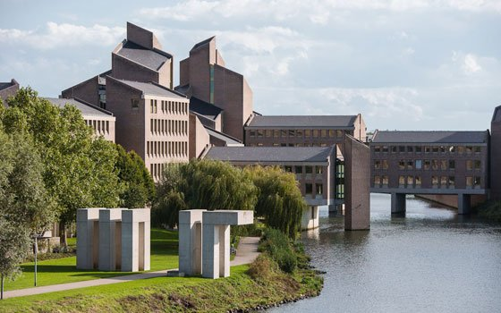

PROGRAMME:
Multiplier event EMBED

Friday 14 December 2018
European Maturity Model for Blended Education (EMBED);
- - 09.00 Registration MID2018 Policy Forum

09.00-09.30 Welcome to the multiplier event of EMBED; Introduction
George Ubachs, managing director EADTU, Coordinator EMBED.

09.30 – 10.30 Framing blended Learning and Education, Katie Goeman, Veerle van Rompaey, Stephan Poelmans, KU Leuven

10.30 – 11.00 Coffee break

11.00 - 12.00 Developing a Maturity model for blended education, Willem van Valkenburg and Wiebe Dijkstra, TU-Delft

12.00 Q & A plenary session

12.30 Closing remarks and next steps

Partnership

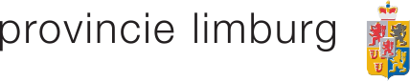

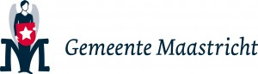

Venue

